**6-3 Assignment: Adding a Temperature and Humidity Sensor**

Chris Bridges

Southern New Hampshire University

CS 350: Emerging Sys Arch & Tech

Professor Bryant Moscon

04 August 2025

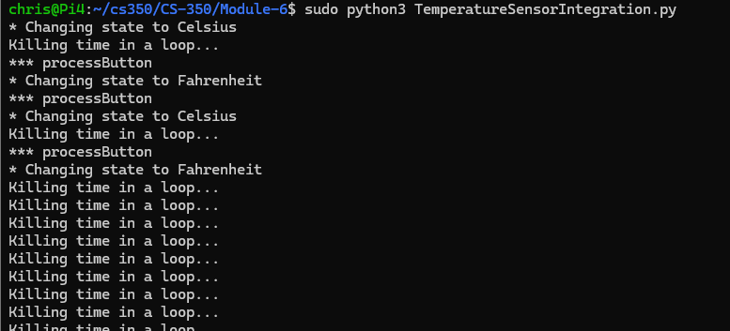

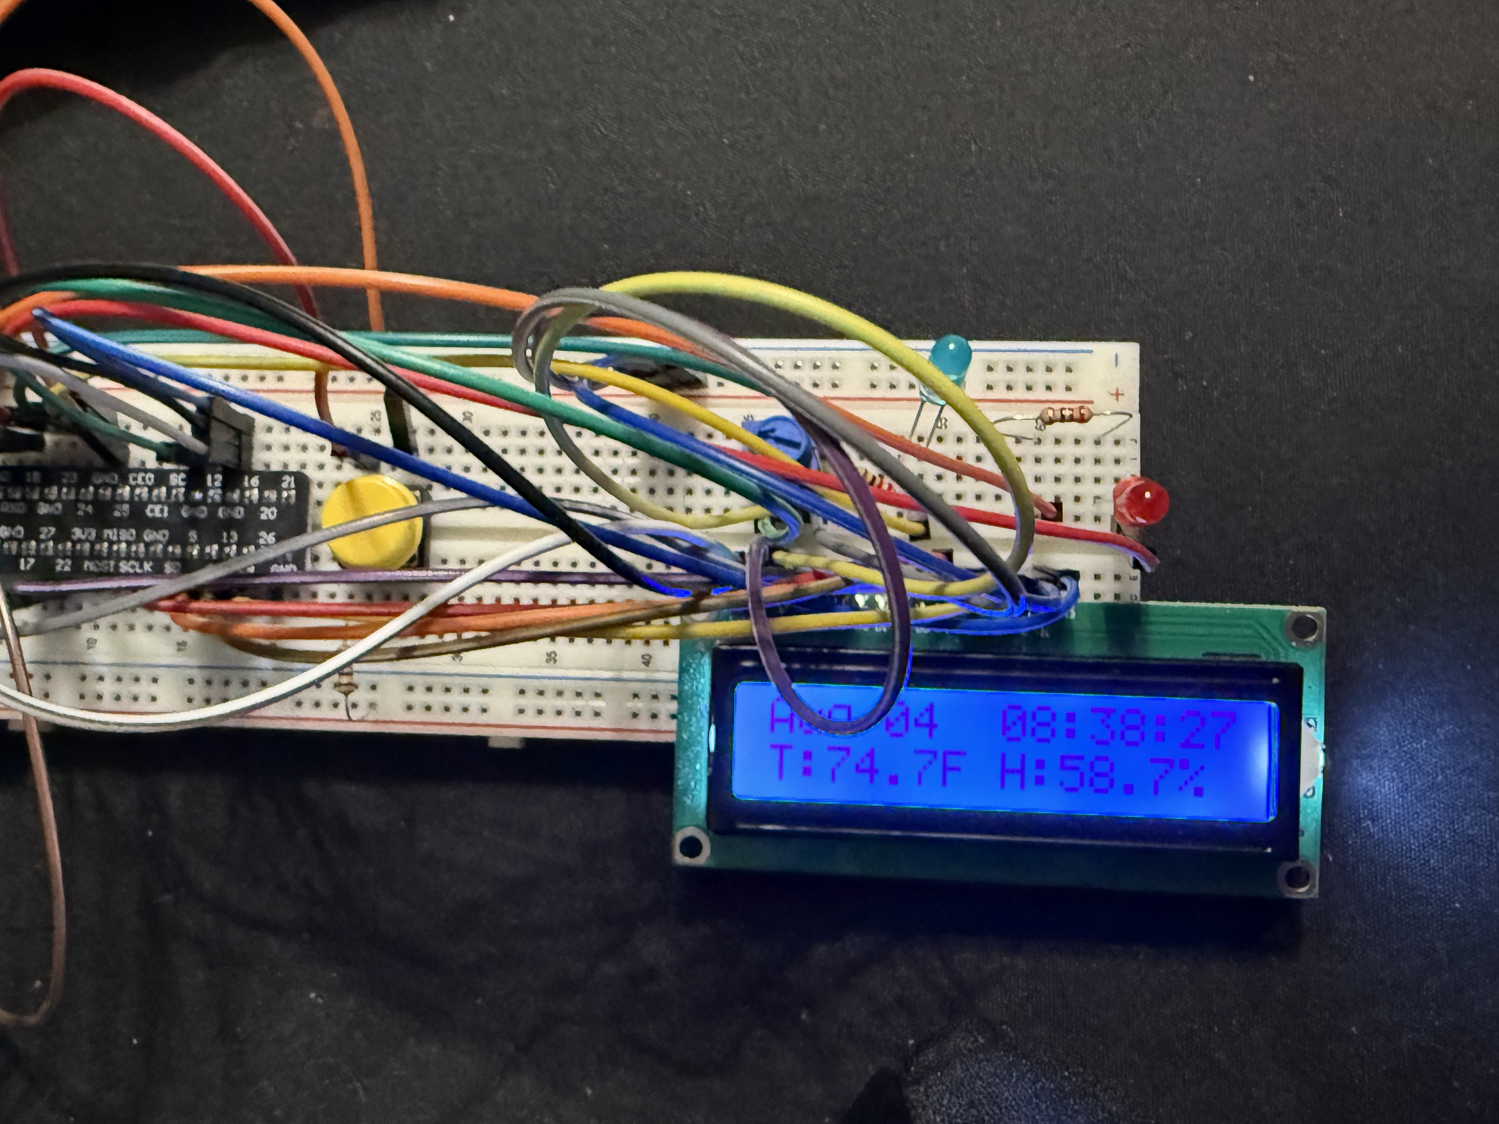

This assignment came together very easily. According to the assignment instructions, some code modifications were required; however, the Python file was already completed. I ran the temperature test program, and the information was displayed in the console. Afterwards, I reviewed the code for the integration program and discovered it was already completed and met all the requirements. I ran the provided Python program, and it met all the listed requirements. The button changed from Celsius to Fahrenheit, the information was displayed on the LCD screen, and the print statements appeared in the command line when the button was pressed.

I followed the instructions for this assignment. I installed the required package, halted processes, and unplugged the device. Installed the temperature and humidity sensor on the previously installed QWIIC cable. I plugged the RPi back in, accessed it via SSH, and ran the 2 programs successfully, without any errors or issues.